North Watford Cemetery
North Western Avenue
Watford
Hertfordshire
WD25 0AW
01923 672157 cemeteries@watford.gov.uk

Pet Panorama
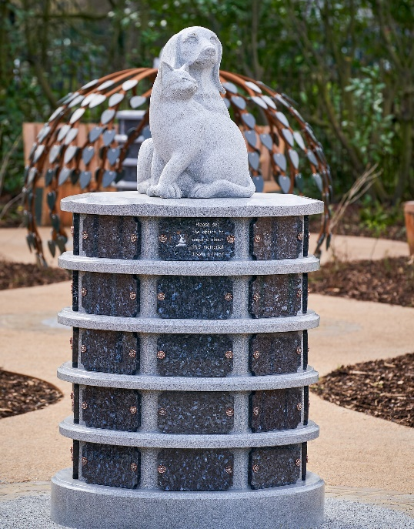

Our Pet Panaroma is a circular above ground columbariaum that holds up to 40 small pet cremated remains in individual vaults with blue pearl granite tablets.

The panaroma is decorated with sculptures of loved pets and set in the peaceful surroundings of our Centenary Garden.

The initial cost of the lease depends on the length of the lease and includes the interment of one small pet’s cremated remains, the initial lease term and a tablet inscription of up to 80 letters. Additional artwork and/or a small photo plaque can also be added to the tablet for an additional fee.

Conditions of lease agreement – Pet Panorama

The leasing of a vault in the Pet Panorama relates only to the provision and placement of one small pet’s cremated remains within the Panorama. The Panorama is provided by and remains the property of Watford Borough Council (the Council) and is not included within the lease agreement. No ownership of that item is inferred to, or may be assumed by, the lease holder. The inscribed tablet remains the property of the lease holder.

In order that the grounds are maintained to the highest standard, the Council reserves the right to upgrade or renew, in similar style, the Panorama or any item, on, or in front of which a vault has been placed.

The option to renew/extend the lease agreement is subject to payment of the fee then applicable.

Prior to the lease expiring, the cemetery will endeavor to contact the lease holder in order that the lease may be extended if they so wish. If the lease expires without renewal, the tablet and cremated remains will be removed from their placement and retained at the office for a 3 month period, during which time the lease holder may collect them. Any items remaining after 3 months will be disposed of sensitively.

The lease holder must advise the cemetery office of any change of address.

Visitors to the grounds must abide by the rules and regulations, copies of which are included with this application and within the cemetery grounds.

The hanging or fixing of flowers, ornaments, personal memorabilia, cards or other similar items on the Panorama or any memorials, trees or any other item within the cemetery grounds is not permitted.

The Council reserves the right to refuse any inscription that is deemed to be unacceptable for display in a public place.

The Council cannot be held responsible for any damage whether accidental or willful that may occur to the plaque whilst in the cemetery grounds.

INSCRIPTION GUIDE BOX FOR PET PANORAMA WITH SCOTIA CORNERS

 | 1 | 2 | 3 | 4 | 5 | 6 | 7 | 8 | 9 | 10 | 11 | 12 | 13 | 14 | 15 | 16 | 17 | 18 | 19
LINE 1

LINE 2

LINE 3

LINE 4
LINE 5
LINE 6

In order to ensure that inscription will fit onto the Pet Panorama Tablet, please note the following information:-

- NO MORE than ONE LETTER or NUMBER must be written in a box.

- DO NOT FORGET TO INCLUDE SPACES IN YOUR INSCRIPTION. A space counts as a letter or number.

- We will centre the text on the tablet; this guide box is only to aid your choice of inscription.

- Blacked out boxes are to represent the holes for the tablet to be fixed to the memorial – DO NOT USE.

- The inscription MUST be clearly written in block capitals. We are unable to accept responsibility for any incorrect inscription due to illegible or ambiguous writing.

If remains are placed in vault before the inscribed tablet is ready, a blank tablet will be fixed in place, if you wish to attend when the inscribed tablet is fitted please indicate here
YES/NO
(If YES we will contact you when the inscribed tablet has been received to arrange a suitable appointment)

RENEWABLE LEASE AGREEMENT FOR PET PANORAMA

Watford Borough Council, (the Grantor) in consideration of the sum of: (£……………………….……….)

Paid to us by: ………………………………………………………………………………………(the Grantee)
(Full name of applicant in BLOCK CAPITALS)

Of: …………………………………………………………………………………………………………………

……………………………………………………………………………………………………………………..
(Address in BLOCK CAPITALS)
Postcode: …………………………………………………………………………………………………………..

Telephone Contacts: Home: ……………………………... Mobile: ………………………………….............

Email Address: …………………………………………………………………………………………………….

- DO HEREBY GRANT UNTO the said Grantee, the right to place one small pet’s cremated remains within vault numbered ..................in the Centenary Garden at North Watford Cemetery for a period of 5/10/15* years from the date hereof.

- This Lease is subject also to the Grounds Rules and Regulations applying from time to time (a copy of the current Rules and Regulations is attached). The Grantee, and their visitors to the vault must abide by the Grounds Rules and Regulations.

- This right may be renewed on its expiry for 5 years on payment of the appropriate fee applicable at that time.

- The vault shall have provision for up to 1 (one) set of small pet cremated remains, subject to suitable containment. The granite tablet will be provided by the Grantor and shall be inscribed only by the Grantor. The granite tablet shall remain the property of the Grantee, who shall care for the tablet during the Lease period.

- The wording of any inscription shall be provided by the Grantee by completing the relevant forms, but the Grantor reserves the right to refuse any inscription, should the wording and content be deemed inappropriate or offensive. The Grantor will arrange for all inscription work to be completed.

- No personal items, memorabilia, trinkets, photographs (other than those provided with the tablet) letters, notes or cards may affixed to the plaque or be placed on or near the Panorama. Any such item may be removed and discarded by the Grantor.

- If, at the end of the lease period, the lease of the vault is not renewed, then, in the absence of any other instructions from the Grantee, after a period of 3 months from the expiry of the lease, the cremated pet remains will be removed from the vault and will be scattered within the Cemetery grounds. This will only be done after reasonable efforts have been made to contact the Grantee**

- The memorial tablet will be retained by the Grantor for 3 months after the lease expires and may be collected by the Grantee within this period. If not collected within that period the tablet will be sensitively recycled.

- The Grantee may terminate this lease at any time during the lease period on giving written notice to the Grantor. The grantee shall arrange collection of the cremated remains from the Cemetery within 4 weeks of giving notice. If the remains are not collected within that period, they will be removed and scattered within the Cemetery Grounds without further notice. The tablet will then be sensitively recycled. No part of the lease fee will be refunded on the termination of the lease.

- It is the responsibility of the Grantee to advise the Grantor of any change of address and to ensure that this lease is renewed. Although the Grantor will endeavour to contact the Grantee before the expiry of the lease, it accepts no responsibility for action taken in the absence of renewal of the lease right, or alternative instructions from the Grantee.

- The Lease relates only to the right to place one small pet’s cremated remains within the vault. The Panorama, and associated areas remain the property of the Council.

- Should there be a repeated or sustained breach of this lease or the Rules and Regulations, the Grantor may immediately terminate this Lease without notice or refund. In such case, the Grantor will notify the Grantee of the termination in writing. The Grantee must arrange to collect the remains from the Cemetery within 4 weeks of the date of the notice. If the remains are not collected within the 4-week period, the remains will be removed and scattered within the Cemetery grounds and the tablet disposed of without further notice.

*Delete as applicable.

** ‘Reasonable attempts’ are defined as being: -
• Telephoning any numbers held on file.
• Emailing via address held on file.
• Writing to the Grantee at the contact address held on file.

I, ……………………………………………………………………………………………………..(the Grantee), confirm that I have read and understood this Lease agreement and the current Grounds Rules and Regulations and agree to be bound by them.
Signed: ............................................................................................................. Grantee
Name
Date: ................................................................................................................
Signed: ............................................................................................................. for Grantor
Name and position
Date: .............................................................................................................

Office Use Only:
Purchase Date | Agreement Number | Receipt Number | Position of pet vault
Expiry Date | Appointment Date & Time | Completed by

