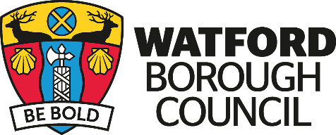

Information on coffins

The standard coffin currently used by Funeral Directors is made of chipboard with a good quality veneer, which looks like real wood. The nameplate, handles and inner linings are all made of artificial materials, mainly plastic. These coffins are used for both burial and cremation. When used for cremation, chipboard coffins cause the majority of the small amount of pollutant emissions that arise. It should also be appreciated that the manufacture of chipboard uses formaldehyde, which is not considered to be environmentally friendly.

There are many alternatives available these days to the bereaved, ranging from American style and ornate coffins to those made of wicker and cardboard.

From 1994, it has been possible to obtain biodegradable (cardboard) coffins. These arose out of the advent of environmental burial schemes opening around the country, and quickly became utilised for traditional burial and cremation. Research undertaken in Europe has proved that cardboard coffins offer a significant reduction in pollutant emissions arising from cremation. These coffins also offer the advantage of lower cost and are rigid, leak proof and easy to carry. Cardboard coffins can also be painted attractively or personalised if so desired. It is possible to cover the coffin with a “pall”, a velvet-type cloth if the cardboard finish is felt to be visually upsetting.

Another recently developed “green” option is the burial shroud. This consists of a board, upon which the body is laid, the whole being wrapped in a large piece of woven, soft, wool cloth. The shroud is sold with black, pure cotton ropes attached for use by four or six bearers. The shroud is suitable for all types of burial, but not for cremation. As a general rule, coffins for burial should be constructed to the smallest size possible for health and safety reasons.

