North Watford Cemetery
North Western Avenue
Watford
Hertfordshire
WD25 0AW
01923 672157 cemeteries@watford.gov.uk

Sanctum 2000
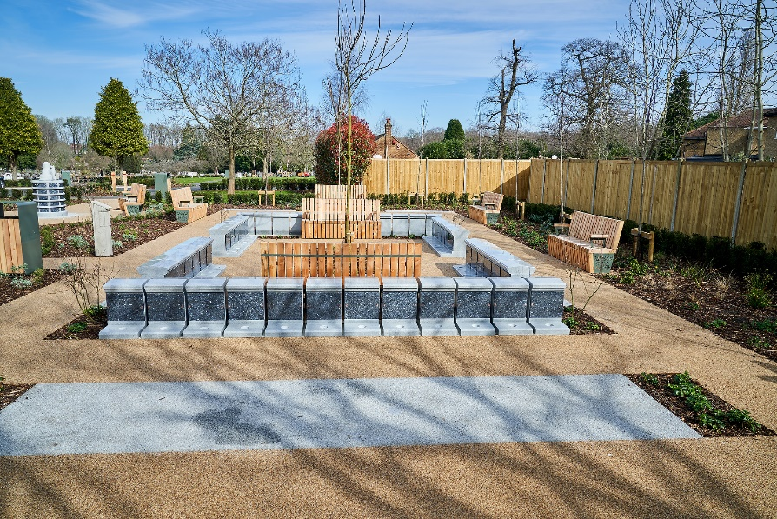

The Sanctum 2000 is an attractive above ground vault for the interment of two sets of remains. The Sanctum has a polished blue pearl granite fascia tablet large enough for a full gilded inscription. The plaques can include a photo or design of your choice from our catalogue or we can work with you to design something individual. The sanctum also includes a vase holder at the front of the tablet for your floral tributes.
Our sanctums have been located in the new Centenary Garden which provides a peaceful place to visit with benches to sit and reflect in beautiful laid out gardens.
The initial cost of the lease depends on the length of the lease and includes the first interment of ashes and an inscription with up to 80 gilded letters.

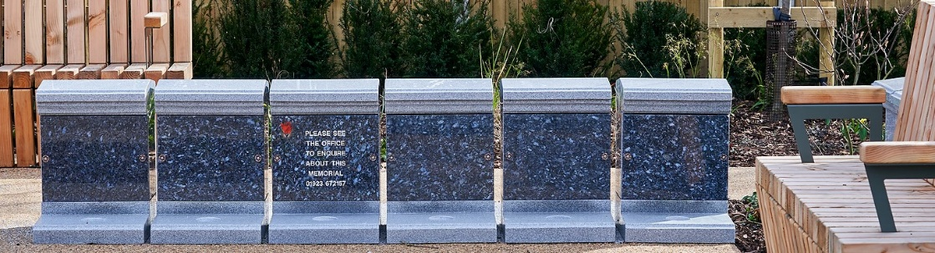

Conditions of lease agreement – Sanctum 2000

The leasing of a sanctum relates only to the provision and placement of up to two cremated remains within the sanctum. The sanctum is provided by and remains the property of Watford Borough Council (the Council) and is not included within the lease agreement. No ownership of that item is inferred to, or may be assumed by, the lease holder. The inscribed tablet remains the property of the lease holder.

In order that the grounds are maintained to the highest standard, the Council reserves the right to upgrade or renew, in similar style, any item, on, or in front of which a sanctum has been placed.

The option to renew/extend the lease agreement is subject to payment of the fee then applicable.

Prior to the lease expiring, the Council will endeavor to contact the lease holder in order that the lease may be extended if they so wish. If the lease expires without renewal, the tablet and cremated remains will be removed from their placement and retained by the Council for a 3 month period, during which time the lease holder may collect them. Any items remaining after 3 months will be disposed of sensitively.

The lease holder must advise the Council’s cemetery office of any change of address.

Visitors to the grounds must abide by the rules and regulations, copies of which are included with this application and within the cemetery grounds.

The hanging or fixing of flowers, ornaments, personal memorabilia, cards or other similar items from memorials, trees or any other item within the grounds is not permitted.

The Council reserves the right to refuse any inscription that is deemed to be unacceptable for display in a public place.

The Council cannot be held responsible for any damage whether accidental or willful that may occur to the plaque whilst in the cemetery grounds.

If remains are placed in a sanctum before the inscribed tablet is ready, a blank tablet will be fixed in place. If you wish to attend when the inscribed tablet is received/fitted please indicate here
Yes/No.
(If YES we will contact you when the inscribed tablet has been received to arrange a suitable appointment)

INSCRIPTION GUIDEBOX FOR SANCTUM 2000 TABLETS
 | 1 | 2 | 3 | 4 | 5 | 6 | 7 | 8 | 9 | 10 | 11 | 12 | 13 | 14 | 15 | 16 | 17 | 18 | 19 | 20 | 21 | 22 | 23 | 24 | 25
LINE 1

LINE 2

LINE 3

LINE 4

LINE 5

LINE 6

LINE 7

LINE 8

LINE 9

LINE 10

LINE 11

In order to ensure that an inscription will fit onto the granite tablet, please note the following information: - Up to 80 letters only before fee applies

The names are in a large typeface and take up more room on the tablet therefore only 18 letters are permitted on Name lines only. (See dotted line).
This is space for two inscriptions, if you require a further inscription on the tablet please ensure that enough lines are left for the inscription. We will centre the inscription on the tablet, the guide box is only to aid your choice of inscription.
Don’t forget to include spaces in your inscription. A space counts as a letter or number. The inscription must be clearly written in block capitals. We are unable to accept responsibility for any incorrect inscription due to illegible or ambiguous writing.
If you require a photo plaque or design, please contact the office for the relevant inscription guide box, this will incur additional charges.

RENEWABLE LEASE AGREEMENT FOR SANCTUM 2000

Watford Borough Council, (the Grantor) in consideration of the sum of: (£………………….…………….)

Paid to it by: ………………………………………..……………………………………………… (the Grantee)
(Full name of applicant in BLOCK CAPITALS)

Of: …………………………………………………………………………………………………………………

……………………………………………………………………………………………………………………..
(Address in BLOCK CAPITALS)
Postcode: …………………………………………………………………………………………………………..

Telephone Contacts: Home: ……………………………... Mobile: ………………………………….............

Email Address: …………………………………………………………………………………………………….

- DO HEREBY GRANT UNTO the said Grantee, the right to place up to 2 sets of cremated remains within sanctum numbered ..................in the Centenary Garden at North Watford cemetery for a period of 10/15/30* years from the date hereof.

- This Lease is subject also to the Grounds Rules and Regulations applying from time to time. A copy of the current Rules and Regulations is attached). The Grantee, and their visitors to the Sanctum must abide by the Grounds Rules and Regulations.

- This Lease may be renewed on its expiry for a further period of [insert number of years it can be extended by 10 years on payment of the appropriate fee applicable at that time.

- The sanctum shall have provision for up to 2 (Two) sets of cremated remains, subject to suitable containment. The granite tablet will be provided by the Grantor and shall be inscribed only by the Grantor. The granite tablet shall remain the property of the Grantee, who shall care for the tablet during the Lease period.

- The wording of any inscription shall be provided by the Grantee by completing the relevant forms, but the Grantor reserves the right to refuse any inscription, should the wording or content be deemed inappropriate or offensive. The Grantor will arrange for all inscription work to be completed.

- One flower container, supplied by the Grantor, may be added to the sanctum, and is included within the initial lease cost. Replacements can be provided at an additional cost.

- Flowers must be placed in the container supplied and must be contained within the width and height of the plaque itself and not overhang or impede the viewing of other plaques. The Council may rearrange or remove flowers that are not positioned in accordance with this clause. .

- Any natural flowers placed within the container may be removed by cemetery staff, once they are considered to have died or their condition has sufficiently deteriorated that they are considered to be detracting from the respectful appearance of the Sanctum.

- Any artificial flowers placed in the container will be removed, should their condition fade or deteriorate to the extent that they are considered to be detracting from the respectful appearance of the Sanctum

- No personal items, memorabilia, trinkets, photographs (other than those provided with the tablet) letters, notes or cards or any other items may affixed to the plaque or be placed on or near the Sanctum. The Council may remove and dispose of any such item.

- If, at the end of the lease period, the lease of the Sanctum is not renewed, then, in the absence of any other instructions from the Grantee, after a period of 3 months from the expiry of the lease, the cremated remains will be removed from the sanctum and will be scattered within the Cemetery grounds. This will only be done after reasonable efforts have been made by the Grantor to contact the Grantee**

- The memorial tablet will be retained by the Grantor for 3 months after the lease period expires and may be collected by the Grantee within this period. If not collected within that period the tablet will be sensitively recycled.

- The Grantee may terminate this lease at any time during the lease period on giving written notice to the Grantor. The Grantee shall arrange collection of the cremated remains from the Cemetery within 4 weeks of giving notice. If the remains are not collected within that period, they will be removed and scattered within the Cemetery Grounds without further notice. The tablet, will then be sensitively recycled. No part of the lease fee will be refunded on the termination of the lease.

- It is the responsibility of the Grantee to advise the Grantor of any change of address and to ensure that this Lease is renewed. Although the Grantor will endeavour to contact the Grantee before the expiry of the lease, it accepts no responsibility for action taken in the absence of renewal of the lease, or alternative instructions from the Grantee.

- This Lease relates only to the right to place cremated remains within the Sanctum. The Sanctum, and surrounding areas remain the property of the Grantor The Grantee may transfer this Lease at any time before it expires, on giving the Grantor written notice and paying the fee applicable at that time.

- In the event of the death of the Grantee, provided the lease has not expired or been transferred, his/her remains may be placed within the vault on instruction of the applicant for their cremation if space is available.

- Should there be a repeated or sustained breach of this lease or of the Rules and Regulations, the Grantor may immediately terminate this Lease without notice or refund. In such case, the Grantor will notify the Grantee of the termination in writing. The Grantee must arrange to collect the remains from the Cemetery within 4weeks of the date of the notice. If the remains are not collected within the 4-week period, the Council may scatter the remains within the Cemetery grounds and dispose of the plaque without further notice.

*Delete as applicable.

** ‘Reasonable attempts’ are defined as being: -
• Telephoning any numbers held on file.
• Emailing via address held on file.
• Writing to the Grantee at the contact address held on file.

I, ……………………………………………………………………………………………………..(the Grantee), confirm that I have read and understood this Lease agreement and the current Grounds Rules and Regulations and agree to be bound by them.
Signed: ............................................................................................................. Grantee
Name
Date: ................................................................................................................
Signed: ............................................................................................................. for Grantor
Name and position
Date: .............................................................................................................
N.B. You will be given a copy of this agreement for your records. Please keep it in a safe place and advise your next of kin/executors of its existence.
To enable us to advise you when this lease is due for renewal or of any essential works required it is important that you keep the Cemetery Office informed of any change of address.
.
In the event of the death of the Grantee please contact the Cemetery Office as the rights to the vault do not automatically transfer to relatives or executors and may have to be formally and legally transferred. This could incur administrative costs and delay any remains being placed within the vault or additional inscriptions being added to the plaque.

Office Use Only:
Purchase Date | Agreement Number | Receipt Number | Position of sanctum
Expiry Date | Appointment Date & Time | Completed by

